

# **Unify Fashion Shop**

Installation Guide

|  |  |  |  |
| --- | --- | --- | --- |
| **Faculty:** | NGÔ PHƯỚC NGUYÊN | |  |
| **Batch No:** | F2-13-1404-S0 | |  |
| **Group No:** | 01 | |  |
| **Students:** |  | **Fullname** | **Roll No.** |
|  | 1. | TRẦN HỮU QUANG | Student806329 |
|  | 2. | NGUYỄN NGỌC CHẤN | Student806304 |
|  | 3. | NGUYỄN THIỆN THUẬT | Student806538 |
|  | 4. | ĐÀM TRỌNG SANG | Student753748 |

**Getting started**

**All procedures, which are described in this file, are based on Microsoft® Windows® XP, WIN7, VISTA. Modify the steps if you are using a different version of Windows. System Requirements: The tables below list requirements for different installation options of Online Caterer. The Notes that identified here apply to both tables.**

1. **System Requirements for Installing Unify Fashion Shop:**
   1. **Hardware:**
      1. **Web Server:**

|  |  |
| --- | --- |
| **Processor** | **Pentium IV or higher** |
| **Memory** | **2 GB RAM or higher** |
| **Modem/ADSL** | **Connecting to internet 24/24** |

* + 1. **Client:**

|  |  |
| --- | --- |
| **Processor** | **Pentium IV or higher.** |
| **Memory** | **1 GB RAM or higher** |
| **Monitor** | **Super VGA (1366x768) or higher resolution with 256 colors** |
| **Pointing Device** | **Microsoft Mouse, Microsoft IntelliMouse®, or compatible pointing device.** |
| **Modem/ADSL** | **Connecting to internet** |

* 1. **Software *:**
     1. **Web Server:**

|  |  |
| --- | --- |
| **Operation System** | **Windows 7/8 or higher.** |
| **Browser** | **Internet Explorer 11.0 or higher.** |
| **Database** | **Microsoft SQL Server 2012** |
| **Software** | **Java SDK 1.7 or above, JDK 8 for glassfish 4.1** |
|  | **Glassfish Full Platform 4.1** |
|  | **SQLJBDC 4.2** |

* + 1. **Client:**

|  |  |
| --- | --- |
| **Operation System** | **Windows 7/8 or higher.** |
| **Browser** | **Internet Explorer 11.0 or higher.** |

1. **Setup Microsoft SQL Server 2012:**
   1. **Open MS SQL Server 2008 Management Studio:**

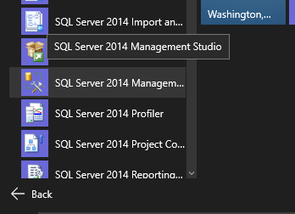**Start > All programs > Microsoft SQL Server 2012 > SQL Server Management Studio**

**NOTE: In picture, I’m using SQL Server 2014 and Window 10. However, Window 7 and SQL Server 2012 should work correctly.**

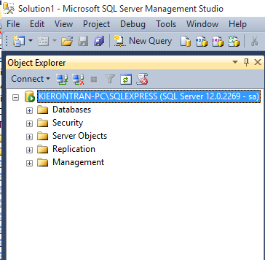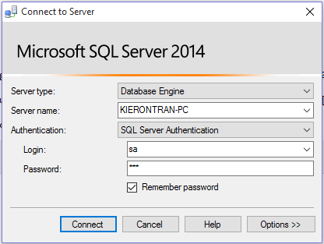**Login to your sql server with username and password**

1. **Setup database: A (using sql script file) or B (using mdf file):** 
   1. **Open Unify.sql file to setup database:**

**Menu File > Open > Files…**

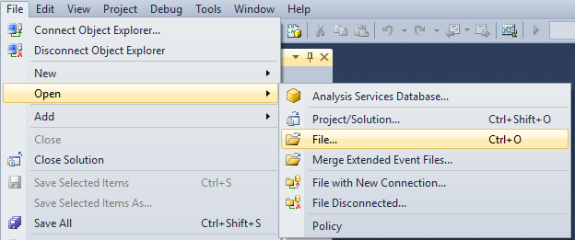

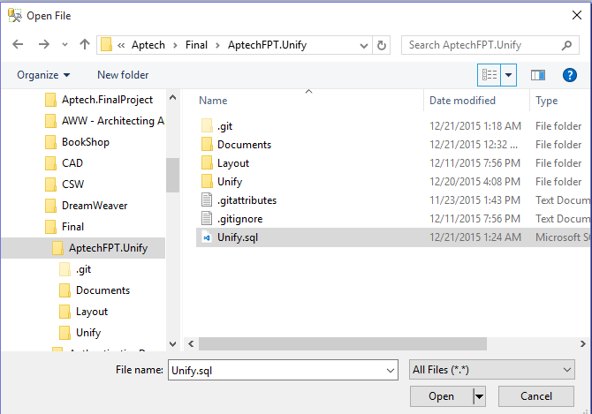

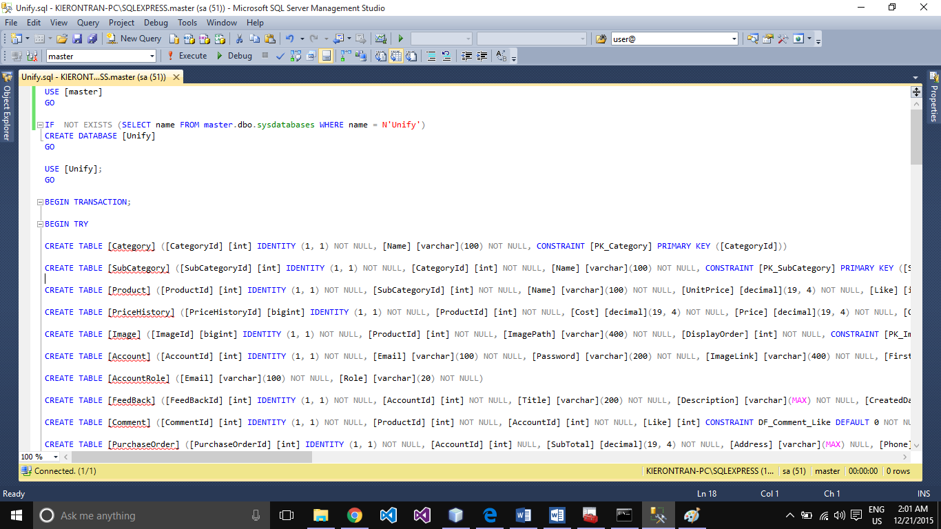**Execute Unify.sql file to create Unify database (Click Execute button on toolbar or Press F5 on keyboard).**

**Right Click Databases > Refresh**

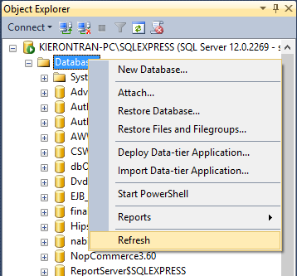

**Result: appear the Unify database in Databases folder**

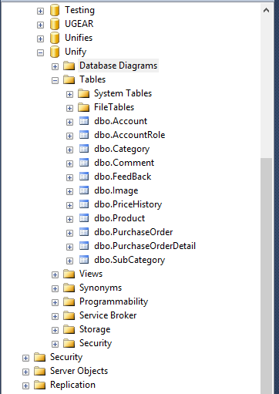

* 1. **Attach Unify.mdf file to setup database:**

**Right click Database > Attach**

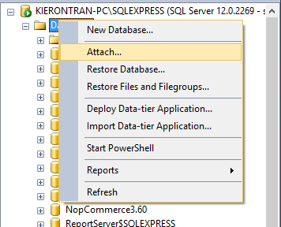

**Attach Database window appear, Select Add button**

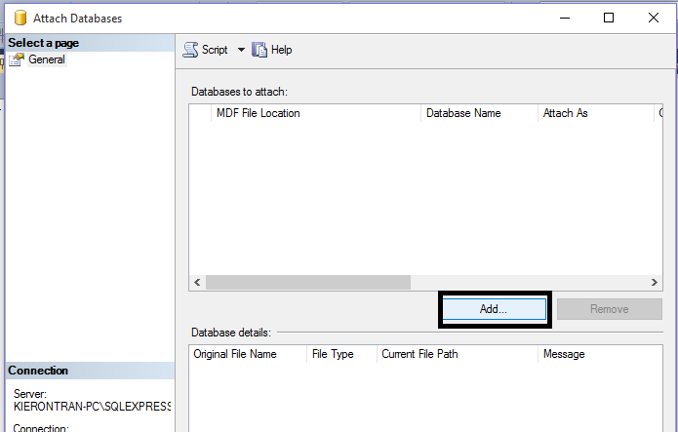

**Select Unify.mdf file in Online Caterer > Database, click OK**

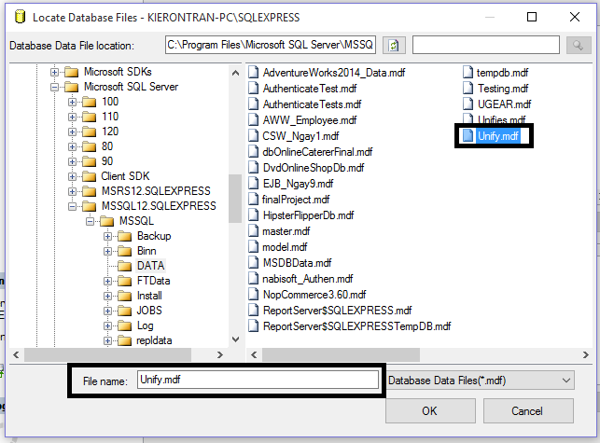

**Create database successfully**

1. **Setup Glassfish v4.1:**

**Link Download:**

[**https://glassfish.java.net/download.html**](https://glassfish.java.net/download.html)

**NOTE: Our Application have some issues with Glassfish 4.0. Therefore, the requirement is Glassfish 4.1 or newer and use JDK 8 u60 or above as Glassfish recommended.**

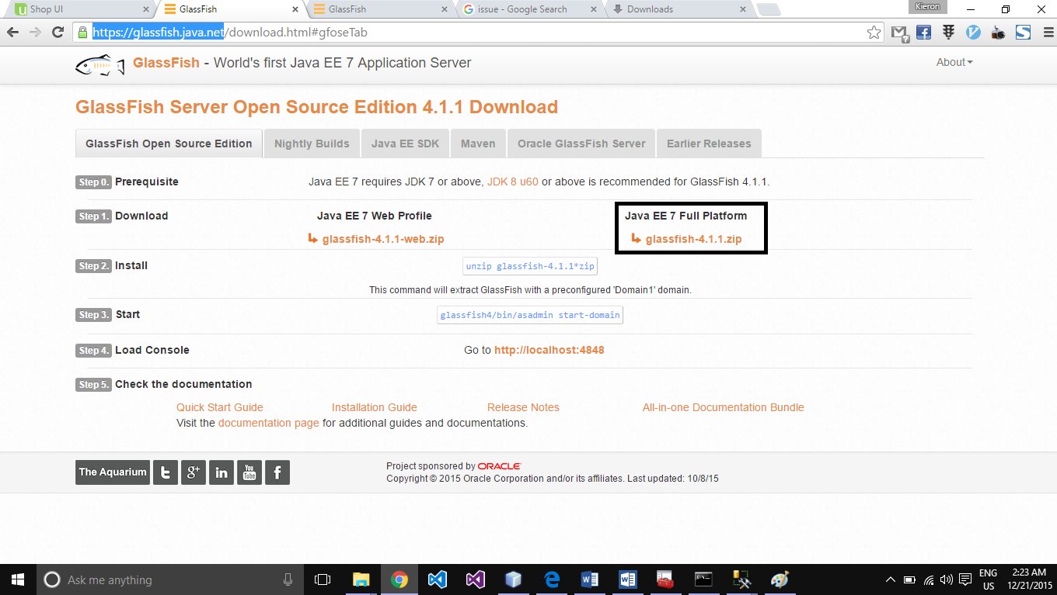

**Extract glassfish-4.1.zip file**

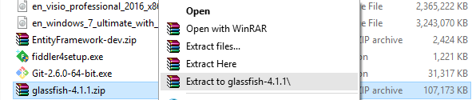

**Put glassfish4 folder where it convenient. Best place is C:\glassfish4 or C:\Program Files\glassfish4**

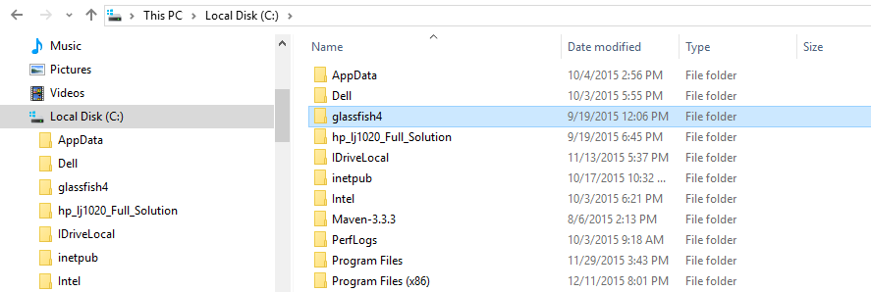

**Step 2: After extract successfully then copy file drivers: sqljdbc4-20.jar**

**Use sqljdbc4-2.0.jar in Unify folder or download sqljdbc4-2.0.jar at** [**http://www.java2s.com/Code/Jar/s/Downloadsqljdbc420jar.htm**](http://www.java2s.com/Code/Jar/s/Downloadsqljdbc420jar.htm) **or** [**https://www.microsoft.com/en-US/download/details.aspx?id=11774**](https://www.microsoft.com/en-US/download/details.aspx?id=11774)

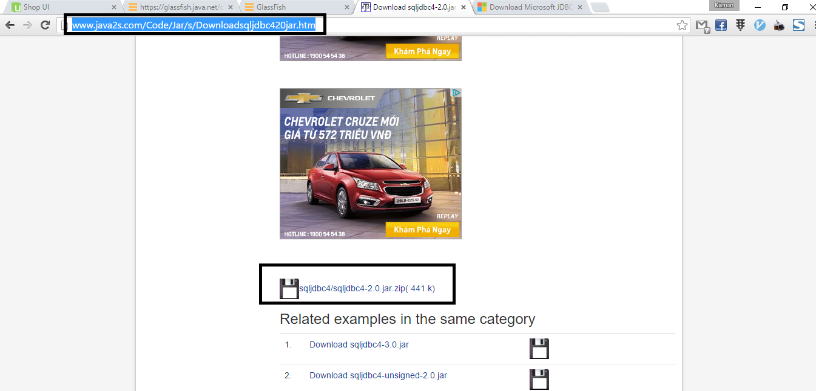

**And put sqljdbc4-2.0.jar into “C:\glassfishv4\glassfish\domains\domain1\lib”:**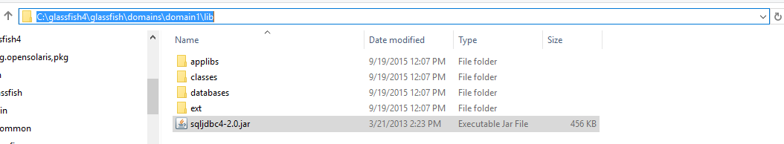

1. **Run Application:**
   1. **Step1: Start glassfish 4.1:**

* **Run as Administrator file “C:\ glassfish4\glassfish\bin\asadmin.bat”**

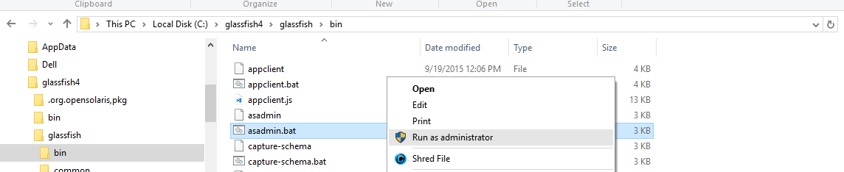

In command prompt window, typing the command line: **start-domain** to start glassfish:

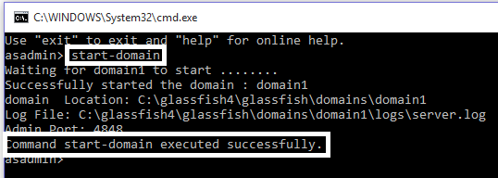

If the server starts successful, “Command start-domain executed successfully” wills be appeared.

NOTE: the server wills run as window services. To able to stop server, Run as Administrator file **asadmin.bat** and execute command **stop-domain**

1. **Step 2: Configuration server for project:**

* **Setting up connection pool:**
* 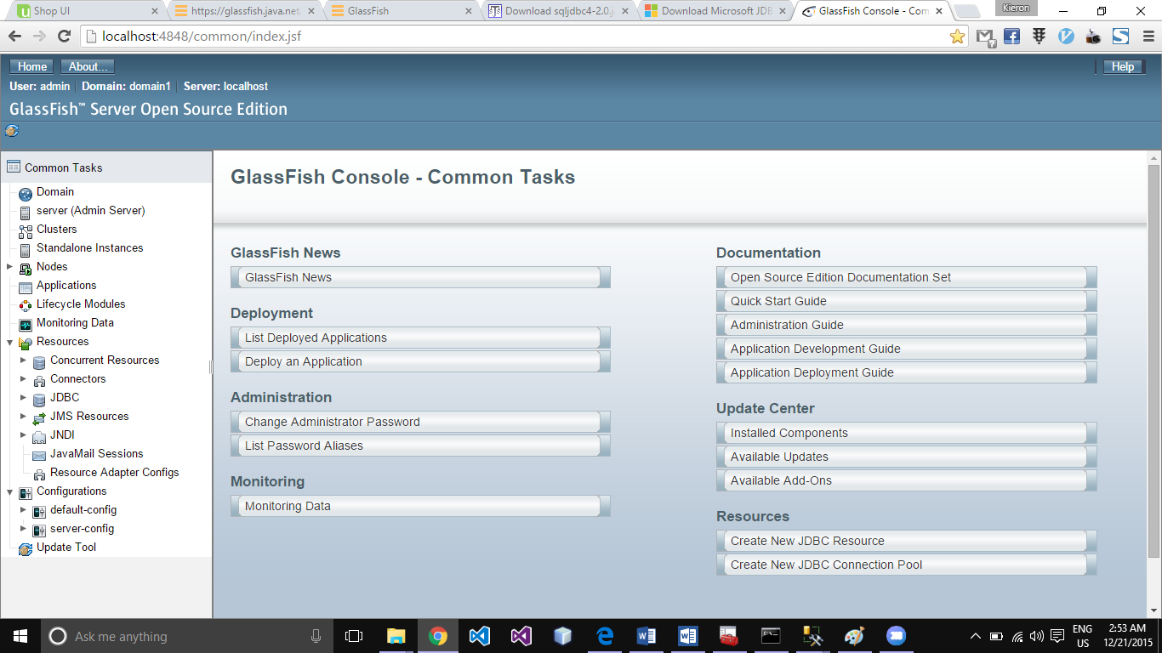Open the browser and type the address: <http://localhost:4848/> .

-To **Resources > JDBC > JDBC Connection Pools > new** for creating new connection pools.

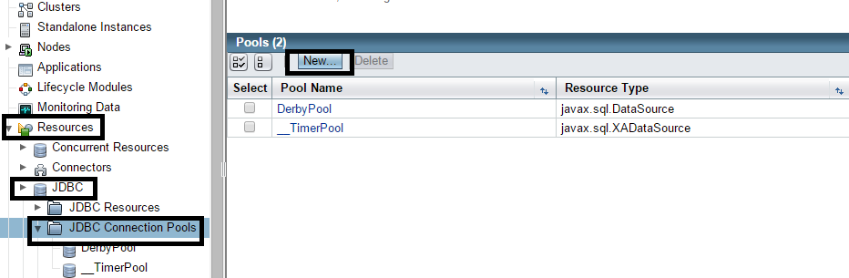

-On **New_JDBC_Connection_Pool** page, typing or choosing these options as following:

- Name: **microsoft_sql_Unify_saPool**

- Resource Type: **javax.sql.DataSource**

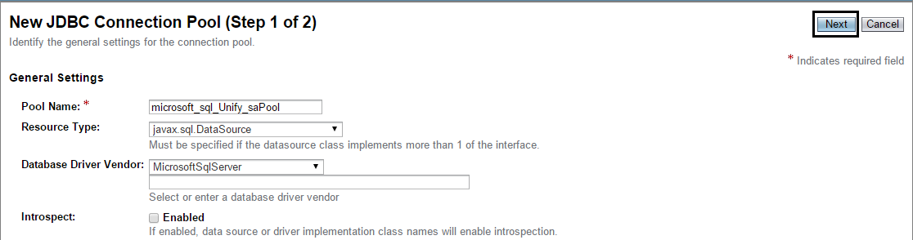- Database Vendor: **MicrosoftSqlServer**

Then click **Next** for next step **New JDBC Connection Pool (Step 2 of 2)**. After that, Scrolling down to **Additional Properties** then typing these information:

- Passsword: **123**

- URL: jdbc:sqlserver://localhost:1433;databaseName=Unify

- User: **sa** 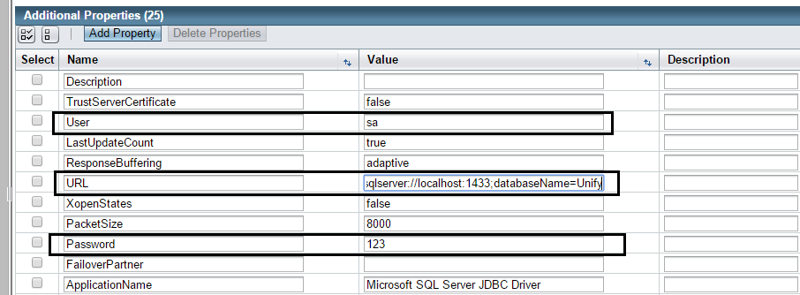

NOTE: **User**: target database username,

**Password**: target database password,

**URL**: target connection string.

Then click **Finish**.

To the next step, testing connection pool:

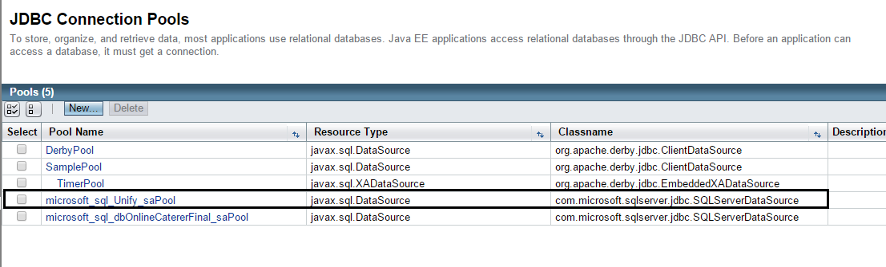

Click **Microsoft_sql_Unify_saPool** to ping database

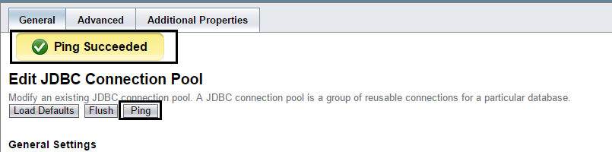

Click ‘**Ping’**, if connect successful, “Ping Succeeded” should appear.

Now create **JDBC Resources** base on **Microsoft_sql_Unify_saPool** to run the Project.

Create a new **JDBC Resources**. Click ‘**JDBC Resources’** and choose **‘New’**

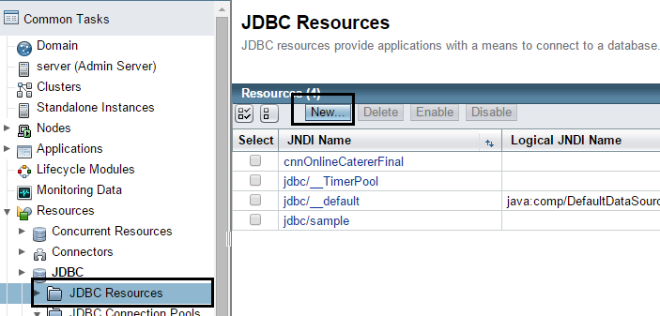

Filling the values in JNDI Name (**Unify**) and Pool Name (**Microsoft_sql_Unify_saPool)** as above. Then click ‘OK’. You’ll see the **Unify** in **JDBC Resources**.

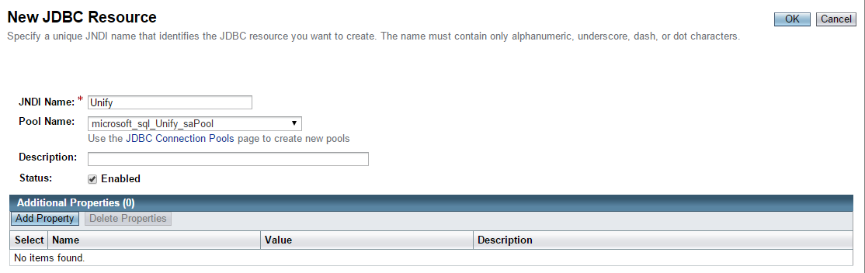

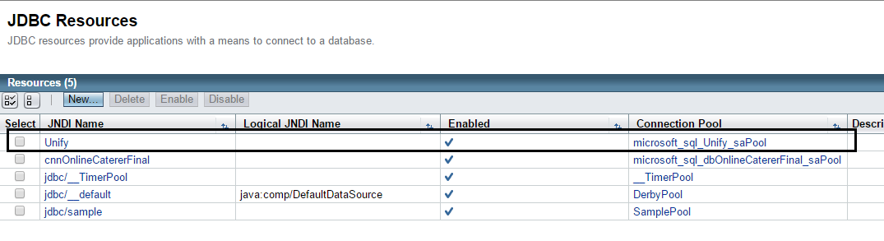

* **Setting up JAAS (Java_Authorization_Authentication_Services):**
* Go to **Configurations > server-config > Security > Realms > New**

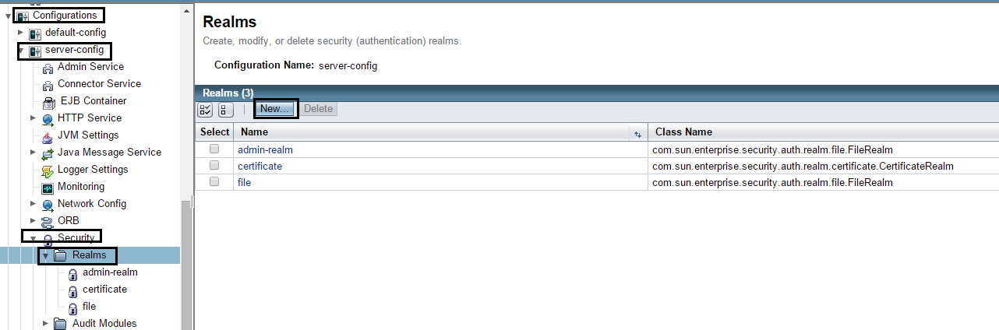

* Typing or chosing these Option as below:
* Name: **UnifyRealm**
* Class Name: **com.sun.enterprise.security.auth.realm.jdbc.JDBCRealm**
* JAAS Context: **jdbcRealm**
* JNDI: **Unify**
* User Table: **Account**
* User Name Column: **Email**
* Password Column: **Password**
* Group Table: **AccountRole**
* Group Name Column: **Role**
* Password Encryption Algorithm: **SHA-512**
* Digest Algorithm: **SHA-512**

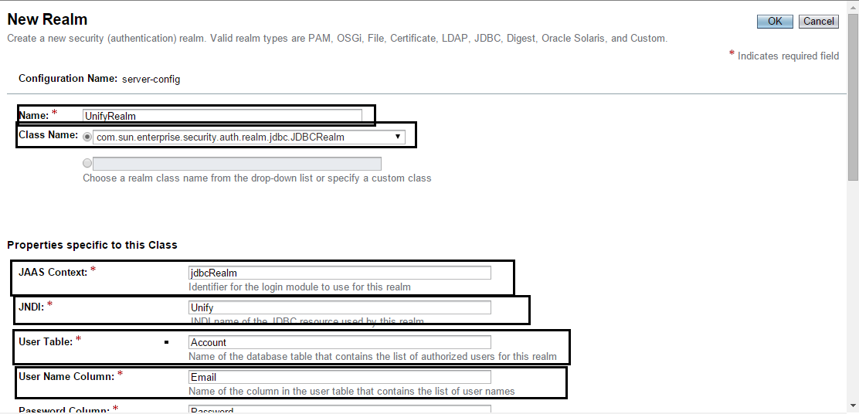

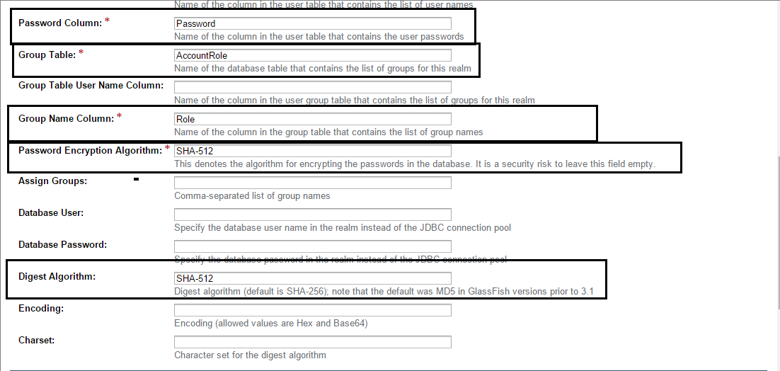

Then click ‘OK’.

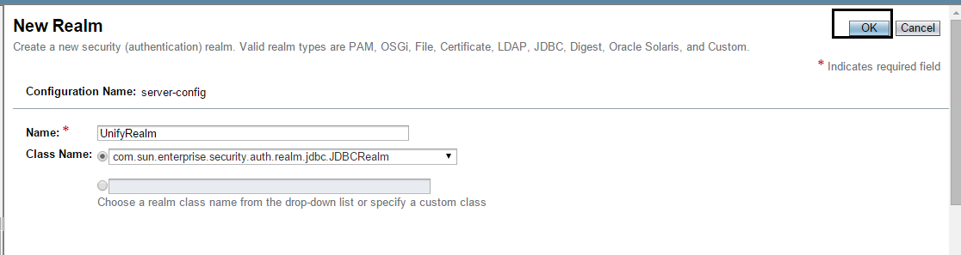

**Realm ‘UnifyRealm’ should appear**: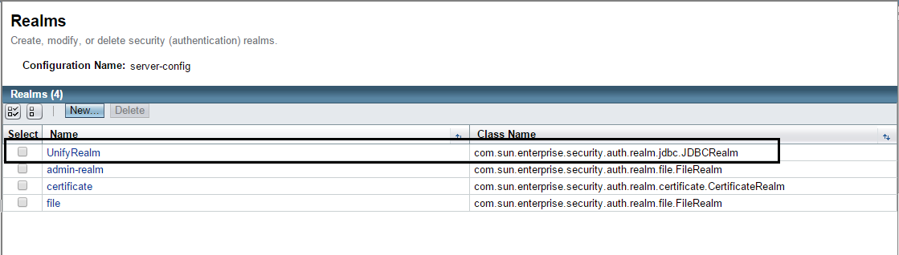

**Restart server to apply changed**.

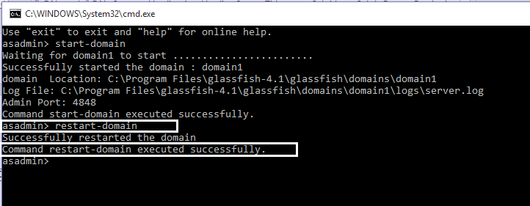

1. **Step 3: Deploy Application**

Now you can deploy Unify Fashion Shop. Click ‘**Application’** and click ‘**Deloy’** button.

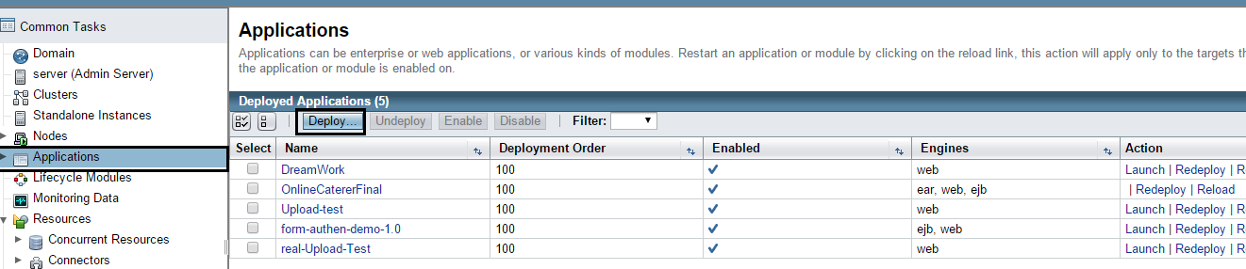

Click ‘**Choose File’** button.

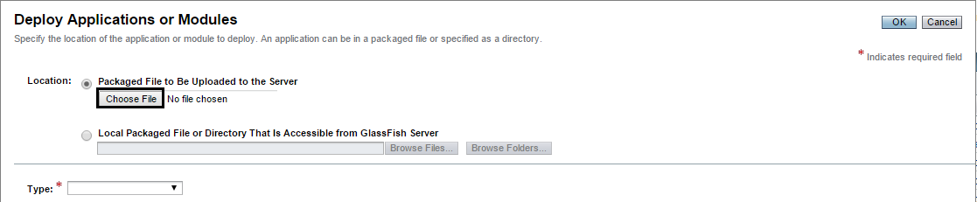

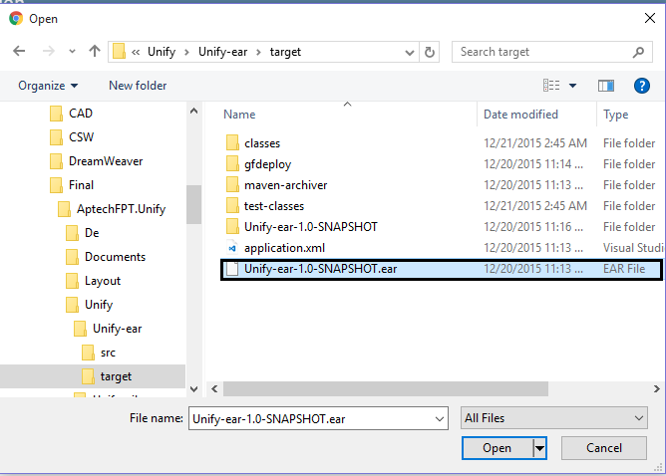

Locate to eProject submittion and choose file **Unify-ear-1.0-SNAPSHOT.ear**

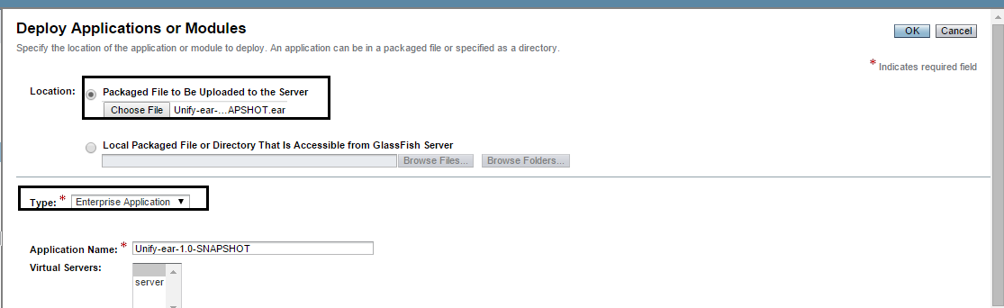

Then click ‘OK’, you’ll see **Unify** in Applications frame

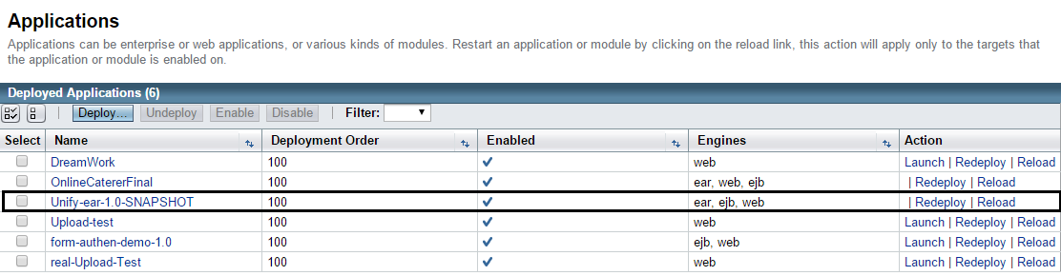

Click **Unify** to launch it

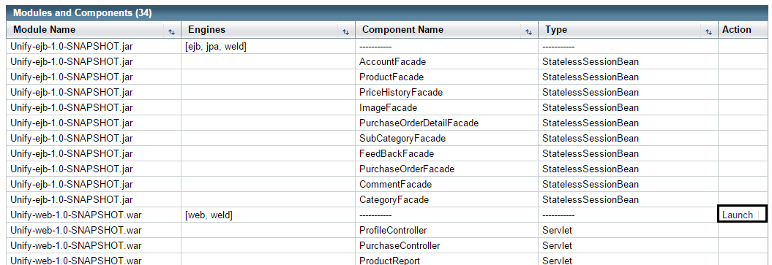

1. **Step 4: Lauch Project Click ‘Launch’.**

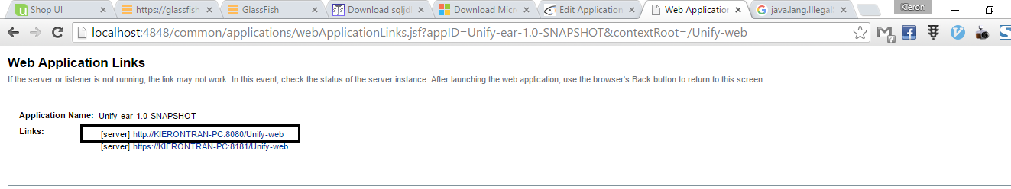

And click <http://KIERONTRAN-PC:8080/Unify-web> and then the first web page will appear for you.



**Run Website on Browser:**

Go to Internet browser type: http://localhost:8080/Unify-web/ on address should use Google Chrome.

Click Sign-In to Login:

Login for Administrator:

UserName: [admin@yourstore.com](mailto:admin@yourstore.com)

Password: 123456

Login for SalePerson:

UserName: [kieron2208@gmail.com](mailto:kieron2208@gmail.com)

Password: 123456

Login for User:

UserName: [user@gmail.com](mailto:user@gmail.com)

Password: 123456

**ENJOY IT**

NOTE: If you have any problems, please let us know (contact us at: kieron2208@gmail.com phone: 0907701007). Thanks!